# **CHAPTER 6**

# **Osteoarthritis Classification using Convolutional Neural Network**

## **6.1 Introduction**

In This chapter the introduction of the applying of deep learning approach, typically the Convolutional Neural Network (CNN) for knee-OA detection and knee-OA stage classification are described.

In OA classification study, the fundamental idea of deep learning approach is applied to OA classification is reported in this section. The fundamental idea is to construct the classifier from a collection of ROIs using deep learning algorithms of this section is illustrated the nature of each Whole knee and knee joint space X-ray image, using deep learning algorithm. The sub-images of Dataset B (As mentioned in chapter 3) are used in this study. With the known class of each sub-image, the Convolutional Neural Network with transfer learning process had been analyse to classify for each sub-image dataset. In this process, AlexNet that is the pretrained model can build classifier which could be used to analyses OA condition.

More specifically, the deep learning approach of transfer learning technique is discussed. In addition the application of using CNN for the given ROIs or sub-image is also presented. To get the joint space more clear for the study, the Otsu’s algorithm was applied to knee joint space sub-image. Thus, three sub-image datasets were applied for this study. Once each sub-image dataset has been obtained the next stage of the data preparation phase is to consider as the input layer which the input layer was processed in the hidden layer then produce as the output layer for the classification result. The CNN was applied in the feature learning of the transfer learning process to remove the feature selection process. The major idea of the study is to adopt the transfer learning technique, especially a Convolutional Neural Network. In case of medical image, in work [81] have been applied CNN for Carotid intima-media thickness (CIMT) test detection. In order to deal with the work with respect in this research, the CNN used the AlexNet pretrained model to learning the object feature in order to detect knee OA. A proposed framework of OA classification using CNN is presented in Figure 6.1.

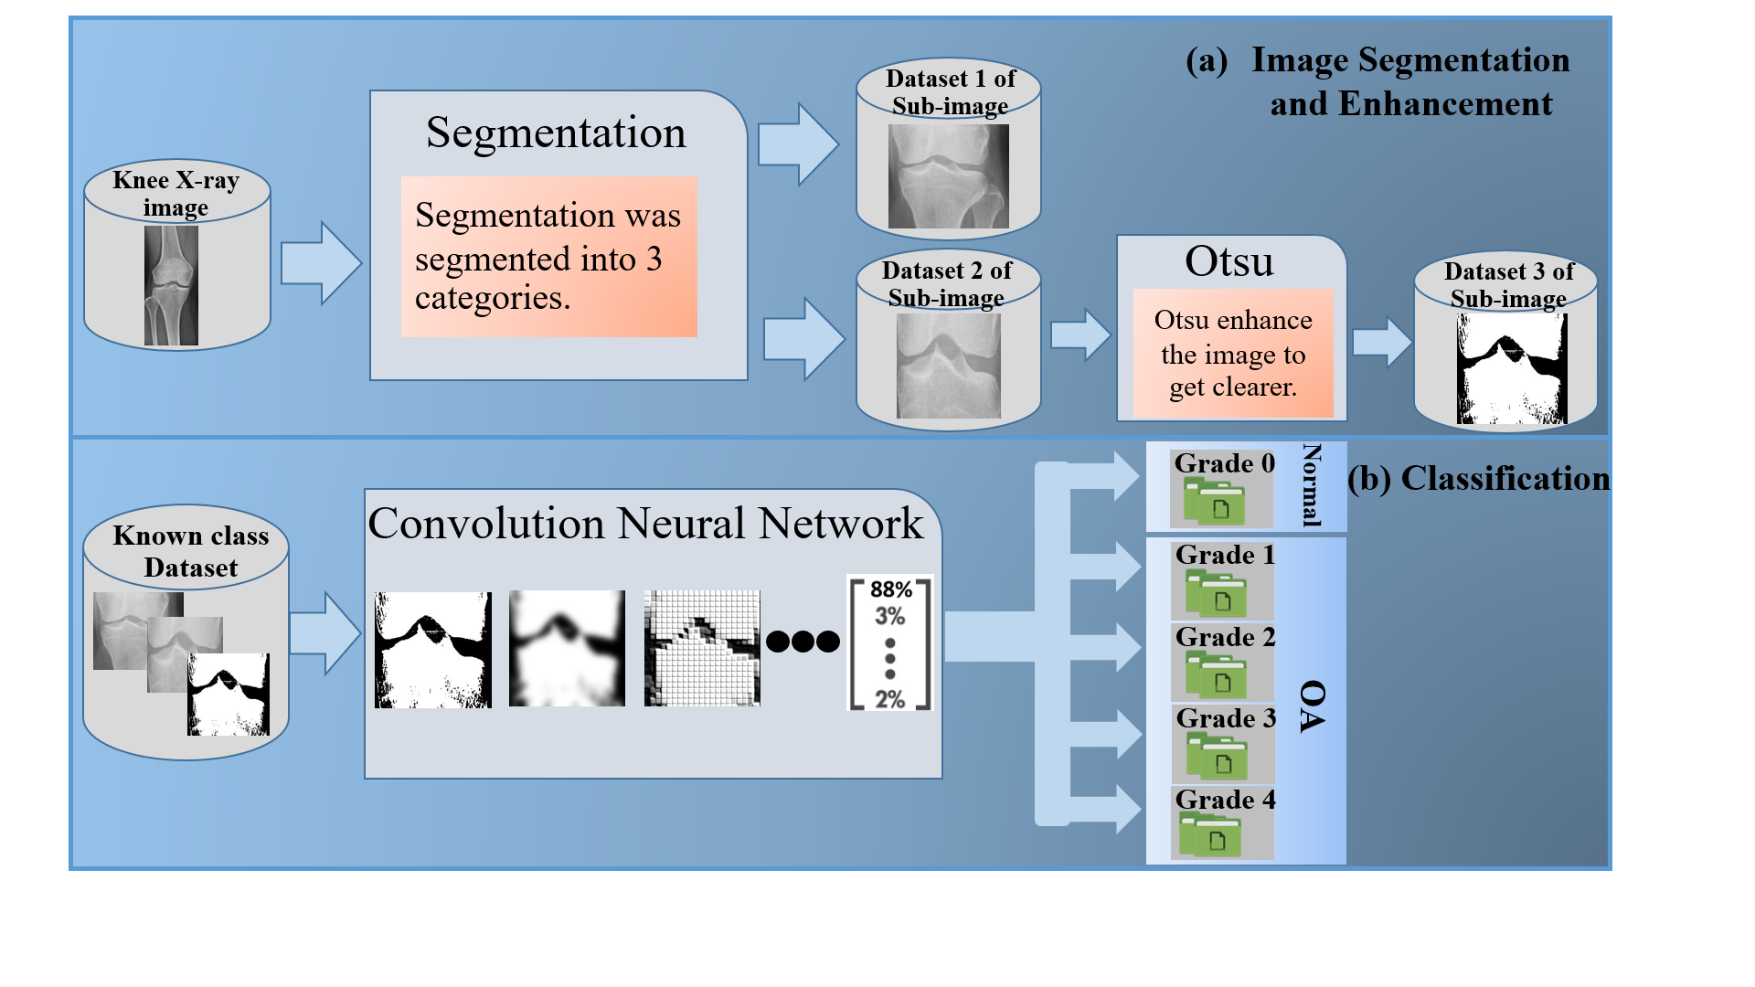

**Figure 6.1** The OA classification by Applying CNN framework

Figure 6.1 illustrated that the transfer learning based of OA classification comprises of two main processes: (a) Image segmentation and Enhancement, and (b) Classification process. The image segmentation and enhancement, the Otsu thresholding method was considered. With respect to the work in this thesis, there are three sub-image datasets that obtained from the segmentation and enhancement process: (i) the whole knee sub-image considered as the *Dataset 1*, (ii) the joint space sub-image considered as the *Dataset 2*, and (iii) the enhancement of joint space sub-image (Otsu implementation) considered as the *Dataset 3*. Once a dataset of each sub-image has been segmented the next process is the transfer learning process with AlexNet pretrained model, the input image data needs to be resize to 227x227 pixels. An isolate a collection of image dataset used in learning process using the image feature in order to understand the nature of each image class.

The rest of this chapter is organised as follow: the information of convolutional neural network with transfer learning is presented in Section 6.2. The evaluation of the studies are demonstrated in Section 6.3 include Sub-section 6.3.1 presents the knee-OA detection evaluation and Sub-section 6.3.2 presents the evaluation of knee-OA stage classification study. The discussion of OA classification studies are presented in Section 6.4. Finally, the summary of the OA classification studies are presented in Section 6.5.

## **6.2 Convolutional Neural Network with AlexNet Transfer Learning**

Deep learning is considered as one of the most famous algorithms of machine learning algorithms. Multi-levels learning have been applied. Deep learning is a technique developed from the artificial neural network which was inspired from human brain neurons connected system. Deep learning has been developed so far in computer vision technology including: image classification, object detection, and image segmentation. Deep learning model has had wiled development for various type of objection, the well-known deep learning model include (i) Autoencoder (AE), (ii) Deep Belief Learning (DBN), (iii) Convolutional Neural Network (CNN), and Recurrent Neural Network (RNN) [31]. With the respect to the study purpose, the convolutional neural network is discussed.

Convolutional neural network (CNN or ConvNet) has been considered as the one of the most popular model for deep learning mechanism. In general CNN model is directly uses for identification and classification tasks of image, video, text, or sound. In the context of CNN application, the CNN directly used to find the patterns in image. Thus, CNN uses the pattern that multi levels learning can learn from image feature to classify image and in CNN work the feature extraction is removed from the process. There are three factors that make CNN widely used in deep learning for classification task: (i) the manual feature extraction is remove when applied with CNN, mean that CNN learn directly to the image feature, (ii) the state-of-art recognition result is produced by CNN, and (iii) when a new recognition task come, the CNN can be retrained and enabling to create on pre-existing network. CNN is similar to other deep learning model. It consists of three important layers: (i) Input layer, (ii) Hidden layer, and (iii) Output layer. The Figure 6.2 illustrates the three layers of CNN deep learning model:

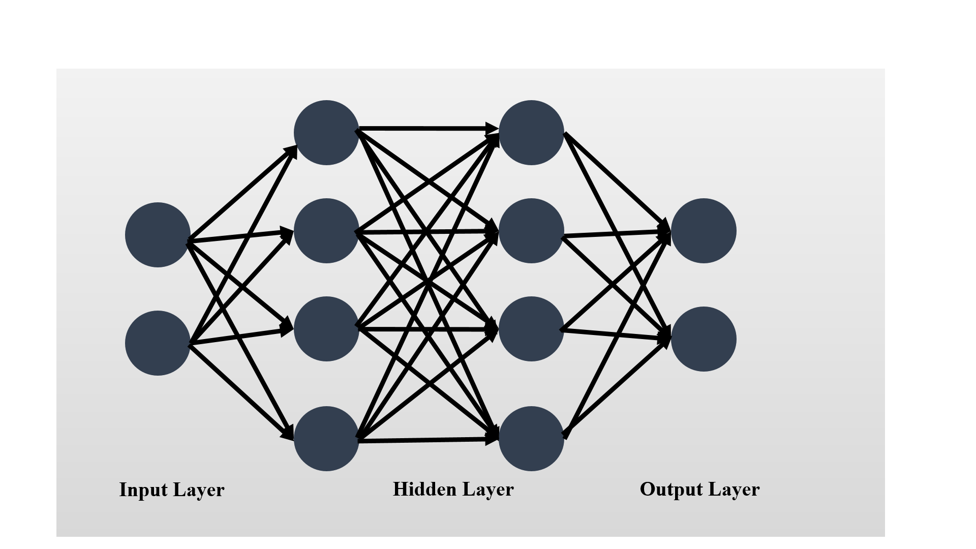

**Figure 6.2** The Three Layers of CNN Deep Learning Model

With the reference to Figure 6.2, the three layers can be operated to the intent of learning feature. In the learning feature process, CNN use the most three common layers: (i) Convolution, (ii) activation or Rectified linear unit (ReLU), and (iii) Polling. Each of these three layer are described in further detail as follow:

* Convolution: the input is brought through a group of convolution filters that can activate certain image feature.
* ReLU: the maintaining positive value and mapping of negative value to zero is presented in order to produce the faster performance and more effective training. In this layer, only the activated features are selected and bring into the next layer that sometime called as activation.
* Pooling: the number of parameter is reduced that the network need to learn this can be call the output of nonlinear downsampling.

CNN application can be learnt by creating or building the CNN from scratch or use the pretrained model with study dataset. With the respect to this study, the pretrained model has been applied, typically AlexNet is the pre-trained model was used for the knee OA classification. AleNet is the CNN pretrained model that has been trained on 1.2 million high resolution image from the ImageNet LSVRC-2010 dataset [83]. The AlexNet model comprises of 23 layers and can be classified 1000 different categories (eg: head, knee, vehicle, cat, dog and etc.). AlexNet contained of 60 million parameters, five convolutional layers, in some of convolutional layer followed by max-pooling layers and three fully connected layers consists of 1000-way sofmax that can separated 1000 different image groups [83]. AlexNet pretrained layers are presented in Table 6.1, layer 1 refers to the input image, and layer 25 is the classification layer. Thus, there are only 23 layers for AlaxNet pretrained network:

**Table 6.1** The 23 Layer of Alex pretrained Network

| **Layer** | **Description** |
| --- | --- |
| 1 'conv1' Convolution | 96 11x11x3 convolutions with stride [4 4] and padding [0 0] |
| 2 'relu1' ReLU | ReLU |
| 3 'norm1' Cross Channel Normalization | cross channel normalization with 5 channels per element |
| 4 'pool1' Max Pooling | 3x3 max pooling with stride [2 2] and padding [0 0] |
| 5 'conv2' Convolution | 256 5x5x48 convolutions with stride [1 1] and padding [2 2] |
| 6 'relu2' ReLU | ReLU |
| 7 'norm2' Cross Channel Normalization | cross channel normalization with 5 channels per element |
| 8 'pool2' Max Pooling | 3x3 max pooling with stride [2 2] and padding [0 0] |
| 9 'conv3' Convolution | 384 3x3x256 convolutions with stride [1 1] and padding [1 1] |
| 10 'relu3' ReLU | ReLU |
| 11 'conv4' Convolution | 384 3x3x192 convolutions with stride [1 1] and padding [1 1] |

**Table 6.1** The 23 Layer of Alex Pre-trained Network

| **Layer** | **Description** |
| --- | --- |
| 12 'relu4' ReLU | ReLU |
| 13 'conv5' Convolution | 256 3x3x192 convolutions with stride [1 1] and padding [1 1] |
| 14 'relu5' ReLU | ReLU |
| 15 'pool5' Max Pooling | 3x3 max pooling with stride [2 2] and padding [0 0] |
| 16 'fc6' Fully Connected | 4096 fully connected layer |
| 17 'relu6' ReLU | ReLU |
| 18 'drop6' Dropout | 50% dropout |
| 29 'fc7' Fully Connected | 4096 fully connected layer |
| 20 'relu7' ReLU | ReLU |
| 21 'drop7' Dropout | 50% dropout |
| 22 ' ' Fully Connected | 5 fully connected layer |
| 23 'prob' Softmax | softmax |

As noted in Chapter 1 Section 1.3 the OA classification study comprised of knee-OA detection and knee-OA stage classification. Thus, AlexNet have been applied with the 128 medical X-ray images OA classification studies. The CNN Alex pretrained of knee X-ray image process is illustrated in Figure 6.3

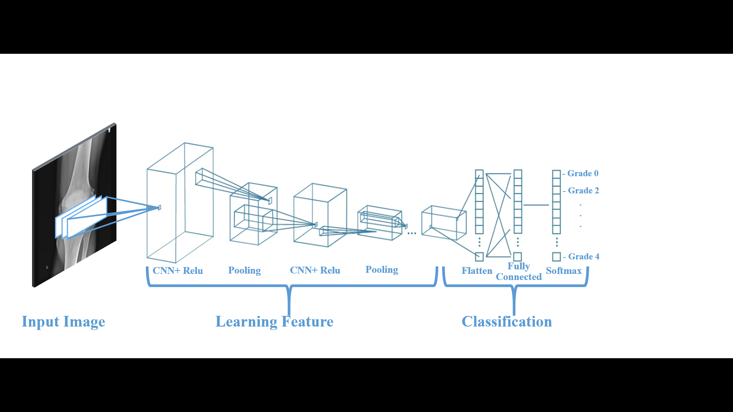

**Figure 6.3** The example of CNN with many convolutional layers applied to Knee

X-ray Imageries.

Figure 6.3 illustrates that the input of images have to be *227x277* square image size, then CNN was applied to learning the feature identify the different image features. After the learning feature that has contain of most three common layers mentioned above, finished in many layers, the architecture of CNN go forward to classification step. In the classification step, the next-to-last layer of classification is the fully connected layer that produce the vector of K dimensions where K is number of classes that network can be used in the prediction of the probability value. The last layers of classification is defined by softmax, this final layer of CNN uses to provide the classification output.

Transfer learning is the commonly applying of deep learning application. In this study, the transfer learning of knee OA classification applied with AlexNet is discussed. In transfer learning, the pretrained network can take whenever the new classification task begin. Transfer learning work quickly and better performance of small image dataset. The Figure 6.4 illustrates the transfer learning mechanism of the study.

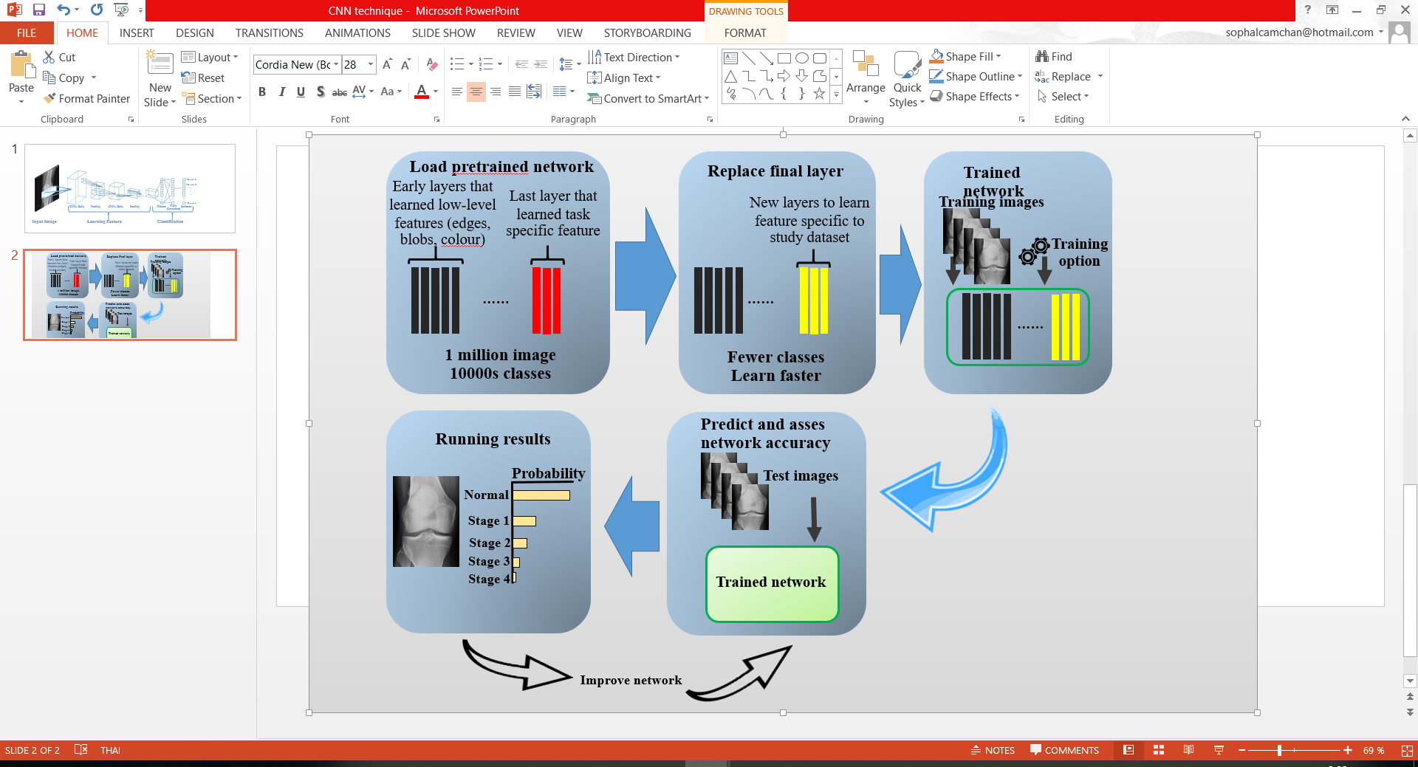

**Figure 6.4** The example of transfer learning to four classes of medical image

From figure 6.4, it can be seen that the process of transfer learning with AlexNet pretrained model. The first process is the applied of AlexNet which has 1 million images to apply the new task of medical image classification, then the second process is the new layer which used to learn to specific to image dataset. Next, the trained network process which is the process taking long time generate of the transfer learning process which can be learnt image feature for identifying the image class, then the predict and asses network accuracy has been applied to each image as the probability value of classification result. Finally, the unseen image could be classified as the probability value. The evaluation of knee-OA detection and knee-OA stage classification using the transfer learning is presented in Section 6.3 as follow.

## **6.3 Evaluation**

As noted before the research study was divided into two main objectives: (i) OA detection and (ii) OA stage Classification. The detail of evaluation is described in Sub-section 6.3.1 and 6.3.2 respectively.

### 6.3.1 Osteoarthritis Detection using Quadtree analysis

For knee-OA detection using CNN is presented here, the evaluation of the transfer learning with AlexNet to detect knee OA is presented in this sub-section. Once, with the three different sub-image dataset have been applied to the study include: (i) Set 1 sub-image (the image of whole knee segmented image), (ii) Set 2 sub-image (the knee joint space segmented image), and (iii) Set 3 sub-image (the implementation of Otsu’s method to Set 2 sub-image). As a result, the result of transfer learning all the sub-image dataset (128 sub-images for each dataset) to knee OA detection study with the value of accuracy of 0.88 (Set 1: AC =0.88, Set 2: AC= 0.88, Set 3: AC= 0.88). However, the study have been extended to study of CNN on the random image of the dataset of (i) 8 images, (ii) 16 images, (ii) 32 images and (iv) 64 images. Table 6.2 reports the accuracy of each dataset:

**Table 6.2** The Accuracy value of CNN application

| No. of image | 8 | 16 | 32 | 64 | 128 |
| --- | --- | --- | --- | --- | --- |
| *Dataset 1* | 0.500 | 0.750 | 0.8333 | 0.833 | 0.880 |
| *Dataset 2* | 1.000 | 1.000 | 1.000 | 1.000 | 0.880 |
| *Dataset 3* | 0.500 | 0.500 | 1.000 | 0.750 | 0.880 |

From Table 6.2 it can be seen that the *dataset 2* sub-image work well for CNN approach with different image dataset (8 image, 16 image and 64 images produce the best accuracy with full value of 1.000). From the result in Table 6.2, the three datasets result can be plotted in the graph which illustrated in Figure 6.5:

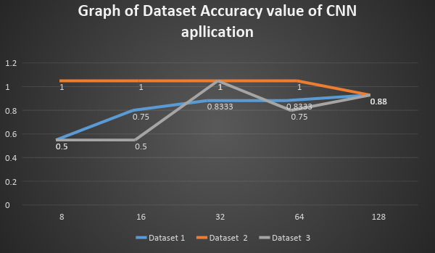

**Figure 6.5** The graph of accuracy for each dataset of CNN application for OA detection

### **5.6.2 Osteoarthritis Stage Classification using quadtree analysis**

The evaluation of the transfer learning with AlexNet model to knee-OA stage classification study is presented in this sub-section. With the respect to the three different sub-image dataset have been applied to the study include: (i) *Dataset* 1 sub-image (the image of whole knee segmented image), (ii) *Dataset* 2 subimage (the knee joint space segmented image), and (iii) *Dataset 3* sub-image (the implementation of Otsu method to *Dataset* 2 sub-image). As a result, the result of transfer learning all the algorithm subimage to knee OA detection illustrated in Table 6.3 below:

**Table 6.3** The Accuracy value of CNN application

| No. of image | 16 | 32 | 64 | 128 |
| --- | --- | --- | --- | --- |
| *Dataset 1* | 0.400 | 0.200 | 0.500 | 0.518 |
| *Dataset 2* | 0.400 | 0.400 | 0.357 | 0.444 |
| *Dataset 3* | 0.400 | 0.200 | 0.500 | 0.629 |

From Table 6.3, it can be seen that the dataset 3 sub-image work well for CNN approach with 128 image dataset. From the result in Table 6.3, the three datasets result can be plotted in the graph which illustrated in Figure 6.6:

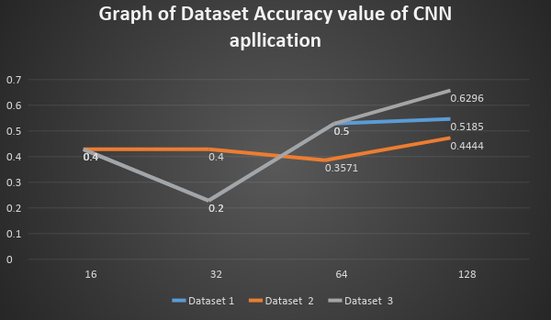

**Figure 6.6** The graph of accuracy for each dataset of CNN application for knee OA

classification

## **6.4 Discussion**

In this section the discussion of knee-OA classification is presented, the CNN deep learning mechanism with AlexNet pre-trained model of transfer learning on OA detection and OA stage classification were considered in this chapter. With the respect to the discussion of Sub-section 6.3.1 and Sub-section 6.3.2, the main findings of chapter presented that in the context of OA detection the *Dataset* 2 sub-image are well predicted for the study, while knee OA stages classification study are well performance by *Dataset* 3 sub-image (the clear joint space sub-image which applied Otsu method), followed by the *Dataset* 1 sub-image (the whole knee segmented image).

## **6.5 Summary**

In short, the chapter presented the CNN deep learning approach with AlexNet transfer learning on knee OA detection and knee OA stages detection study. Thus, in the chapter mainly focused two study approach: (i) OA detection and (ii) OA stages detection. For OA detection study based on transfer learning with AlexNet was presented in Sub-section 6.3.1 and OA stages detection was pictured in Sub-section 6.3.2. Base on the reported of each section shown that: for Set 2 sub-image were well produced for knee OA detection, while the *Dataset* 3 sub-image dataset was well produce for knee OA stages classification study.